**CARRERA:** Ingeniería en Telecomunicaciones

**FECHA:** 25-06-2021

**MATERIA:** PROGRAMACIÓN ORIENTADA A OBJETOS

**NRC:** 3730

**DOCENTE:** ING. JORGE LASCANO, PHD, MS

**WS-10 INSPECTION**

Inspector :Group 4

Group 5 inspections

GitHub /50

Requirements 9.5/10 Do not specify data

Use Case D 8.5 /10y There is no table and order

This diagram must not have multiplicity

Class D 9/10 There is no dependency between TourGuide and City

-There is no association between TourGuide and City

-There is no association between Country and City

Code 9 /10 -does not occupy the camelcase

-missing use the function

Executable 10/10

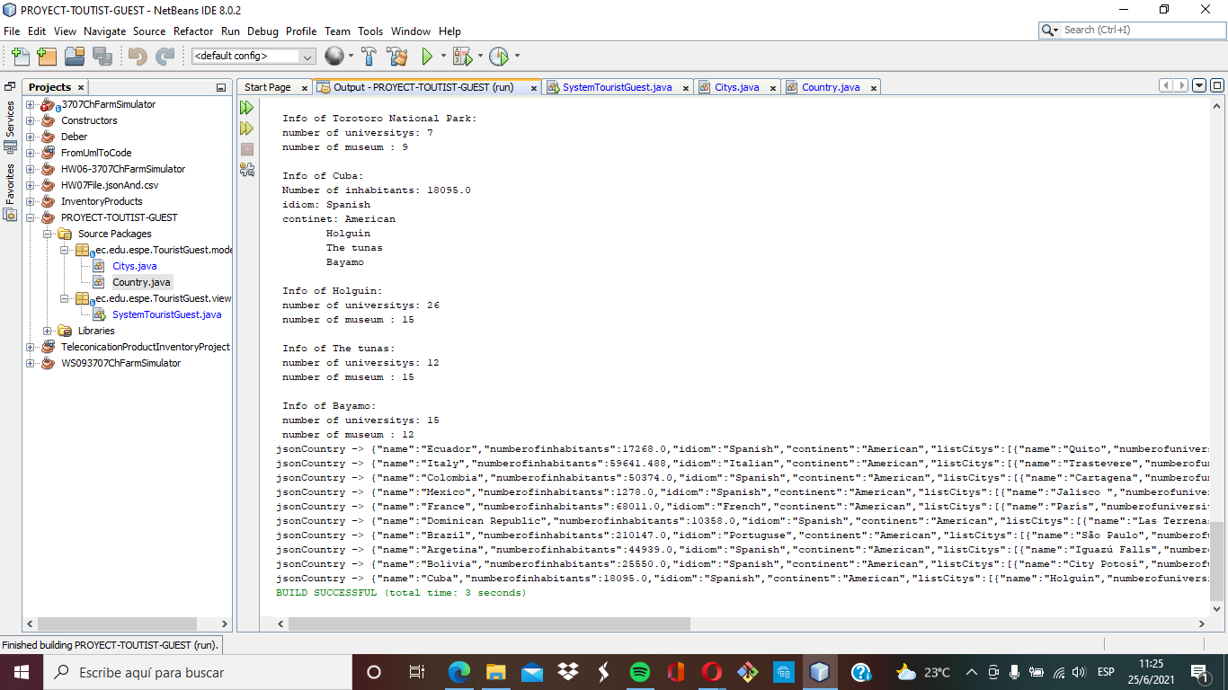

Recommendation:

-Reformulate the class diagram with dependencies and associations

-Rearrange the case diagram was used

-Declare variables using camelCase correctly

-Generate the function to reduce lines of code in the main